Course Methods test 4 Year 12

Student name: ________________ Teacher name: ________________

Task type: Response

Time allowed for this task: ___40________ mins

Number of questions: ____6_______

Materials required: Calculator with CAS capability (to be provided by the student)

Standard items: Pens (blue/black preferred), pencils (including coloured), sharpener, correction fluid/tape, eraser, ruler, highlighters

Special items: Drawing instruments, templates, notes on one unfolded sheet of
A4 paper, and up to three calculators approved for use in the WACE examinations

Marks available: ___45___ marks

Task weighting: _10___%

Formula sheet provided: Yes

Note: All part questions worth more than 2 marks require working to obtain full marks
Q1 (3 marks)
Mary who goes to Perth Modern scored 67% in her exam which had a mean of 65% and a standard deviation of 18%. John who goes to Rossmoyne scored 62% in an exam with a mean of 58% and a standard deviation of 12%. Using standard scores, explain who had the better result.

Solution
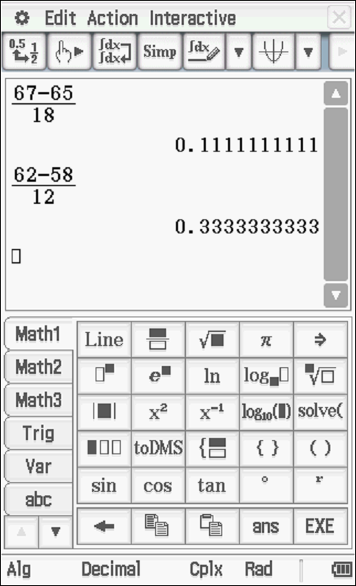
John has the higher z score hence better result.

Specific behaviours
P shows calculation for z scores
P states both z scores
P states that John had the better result

Q2 (3 marks)
Given that and that , determine the value of to two decimal places.
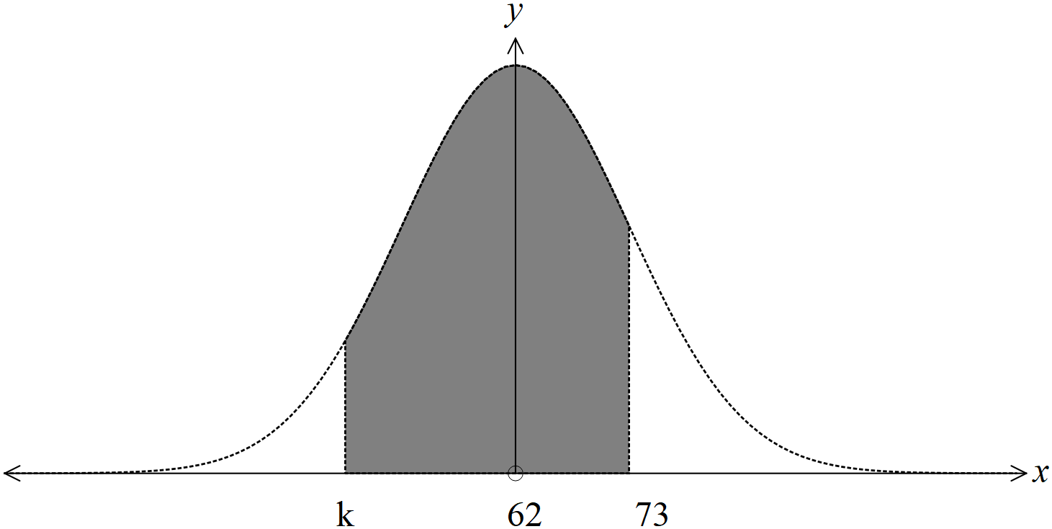

Solution
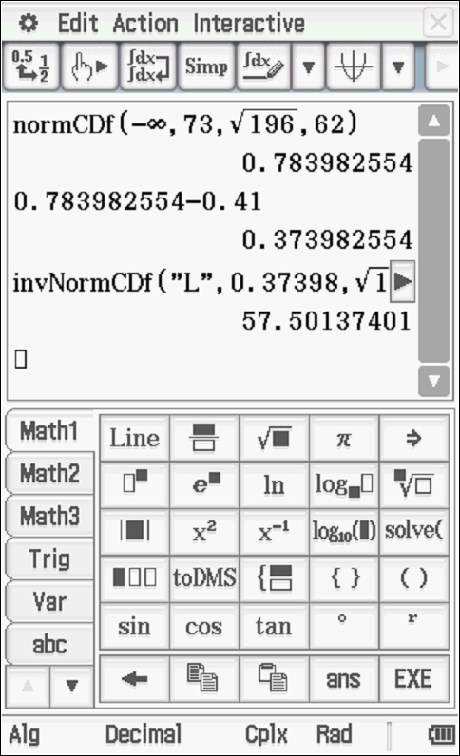
Accept below as working but not recommended in WACE!!!
InvNormCDf (L, 0.37398, 14, 62) = 57.50
k = 57.50
Specific behaviours
P determines prob less than 73
P subtracts to find area below k
P determines value of k to 2 dp
(Note- max 2 marks if working not shown)
Q3 (10 marks)
The lengths of telephone calls, in minutes, in Perth are Normally distributed with . Calls that are longer than 17 mins are charged at double rate and are known as SUPER calls.

- Determine the proportion of calls that are between 11 and 17 mins. (2 marks)

Solution
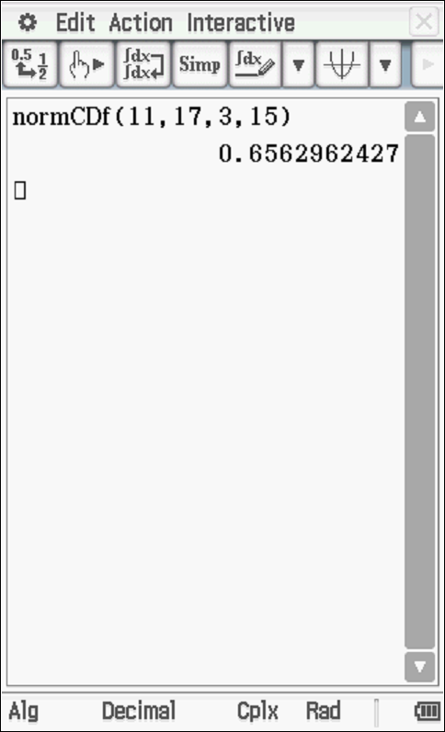

Specific behaviours
P uses correct parameters
P states prob

- Given that a call is less than 13 mins, determine the probability that the call is greater than
9 mins. (3 marks)

Solution
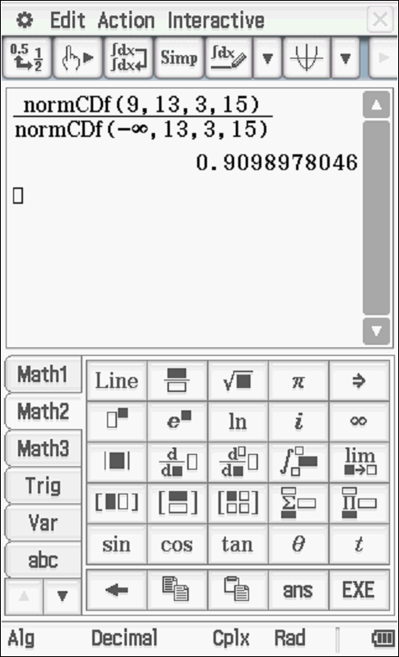

Specific behaviours
P uses conditional prob formula
P shows calculation for numerator and denominator
P states prob

- If the length of the call is in the lower 20% of calls, the call is not charged at all. Determine the longest length of call that is not charged to the nearest second. (2 marks)

Solution
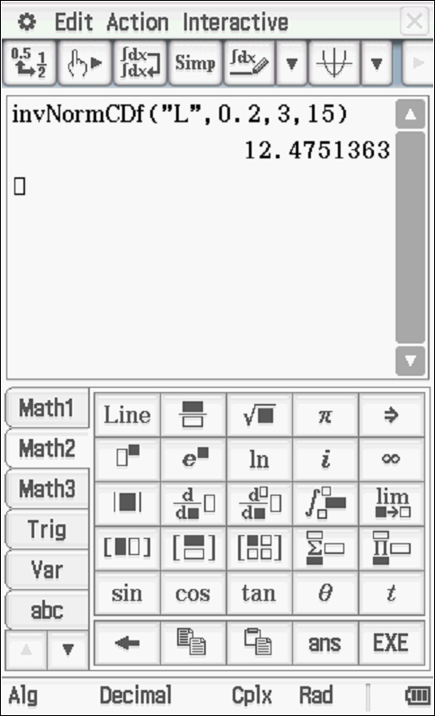

Longest call 12 mins 29 secs (accept 12 mins 28 secs)
Specific behaviours
P uses correct parameters
P states to nearest second (do not accept decimal mins)

- In Sydney the calls are also Normally distributed with a mean of 19 mins. If 25% of all calls are greater than 24 mins, determine the standard deviation to two decimal places. (3 marks)
Solution
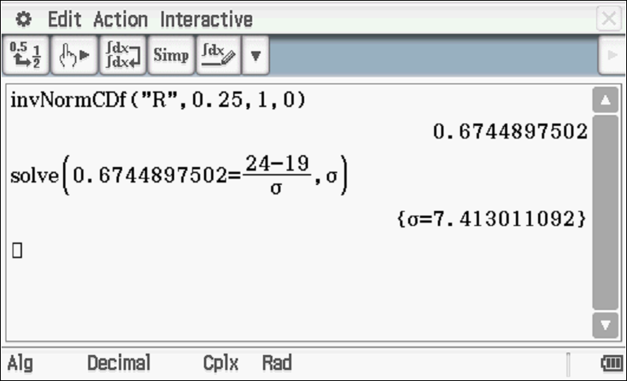

Specific behaviours
P solves for z score
P sets up equation for standard deviation
P solves for standard deviation

Q4 (15 marks)
In a particular city it is estimated that 30% of the population have blue eyes. A sample of 250 people is chosen and the number of blue eyed people are counted. The statistician will assume a Binomial distribution.
- State two reasons why the statistician believes that a Binomial distribution is appropriate.
(2 marks)

Solution
The probability is independent of other people.

The probability is fixed.

Specific behaviours
P states one reason
P states two reasons

- Determine the probability that at least 75 people of the sample have blue eyes. (2 marks)

Solution
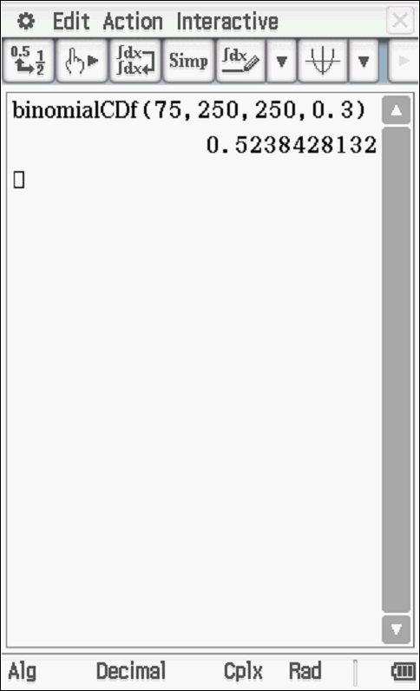

Specific behaviours
P uses Binomial with correct parameters
P states prob
(Do not accept Normal-zero)

For each sample of 250 people the number of blue eyed people are counted and a sample proportion is calculated.
- State the approximate distribution of these sample proportions including all features.
(2 marks)

Solution
Normal Distribution
Mean =0.3
Standard deviation = 0.0290

Specific behaviours
P states Normal
P states mean and approx. st dev

- Determine the approximate probability that a sample proportion will be greater than 0.35.
(2 marks)

Solution
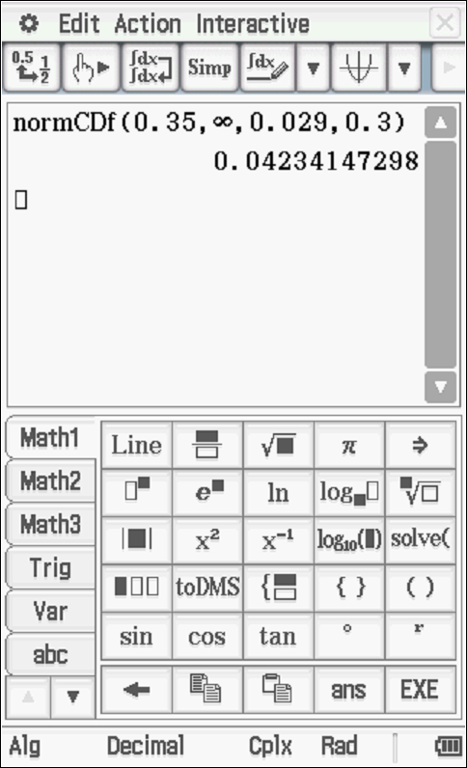

Specific behaviours
P uses Normal with correct parameters
P states prob

- One sample of 250 people had 65 with blue eyes. Determine a 90% confidence interval for the population proportion to 3 decimal places. (3 marks)

Solution
Specific behaviours
P states z score
P states interval
P rounds to 3 dp

- Another three samples of 250 people were taken and the number of blue eyed people were counted. See below. One of these samples is not from the city above. Explain which sample it is and justify your answer using confidence intervals (4 marks)

Sample | Number of blue eyed people
A | 55
B | 72
C | 41

Solution

Most probably Sample C as the confidence interval does not overlap with interval first calculated.
OR
We simply do not know whether any of the above intervals contain the true value of p as not all confidence intervals are expected to contain the true population p. Therefore no inference can be made.
Specific behaviours
P obtains at least one confidence interval of samples A,B&C
P obtains confidence intervals for all samples
P gives an argument that mentions confidence intervals
P identifies sample C OR no inference possible

Q5 (2, 2 & 3 = 7 marks)
Consider a 90% confidence interval that has a margin of error of units. Assume that the sample proportion does not change.
Answer in terms of .
- Determine the new margin of error if the sample size is nine times the original.

Solution
Specific behaviours
P uses inverse proportion with square root
P states in terms of a

- Determine the new margin of error if the sample size is unchanged but the confidence is decreased to 75%. (2 decimal places).

Solution
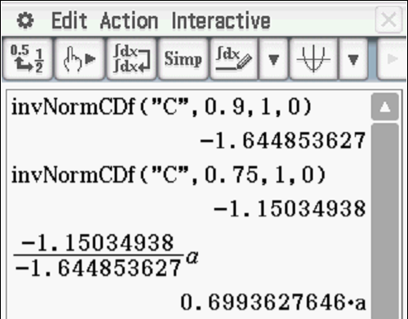

Margin = 0.70a

xSpecific behaviours
P determines z scores for both confidences
P states in terms of a (no need to round)

- Determine the new width of the confidence interval if a confidence of 97% is used and the sample size being one third of the original size. (2 decimal places)

Solution
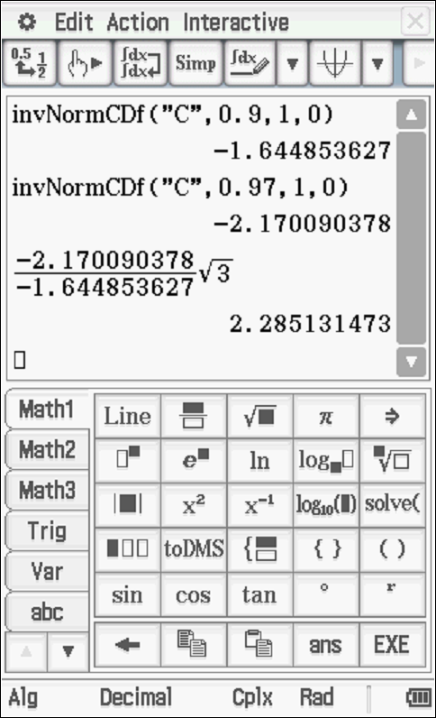
New width = double of 2.285a=4.57a

Specific behaviours
P determines all z scores
P divides z scores and multiplies by root 3
P doubles and states in terms of a

Q6 (7 marks)
A traffic consultant has been hired to determine the proportion of people who drive to work.

- A confidence interval of 82% will be used with an error within 0.015. Determine the minimum sample size that should be selected. (3 marks)

Solution
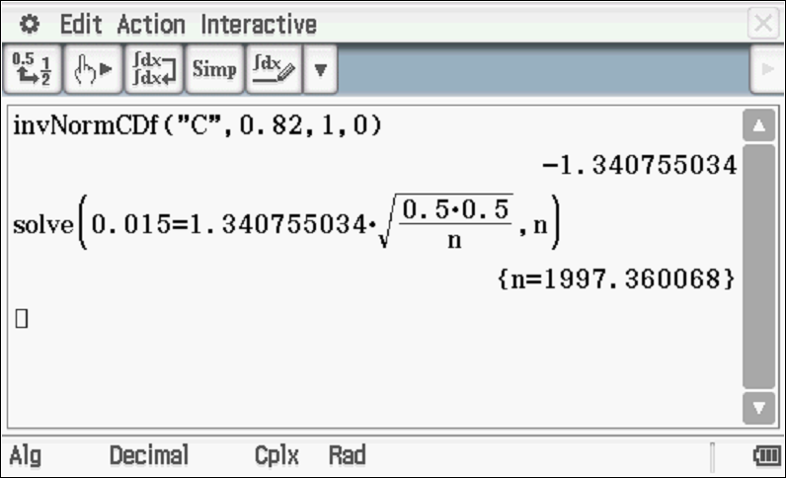

n= 1998
Accept 1996-1999 due to various rounding of z score.
Specific behaviours
P sets up equation for n using p=0.5
P solves for decimal value
P round up

- If the maximum sample size is 720 people, determine the maximum error in estimating a 95% confidence interval. (2 marks)

Solution
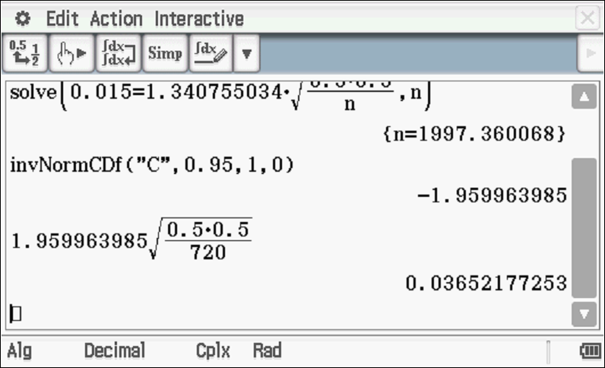

Specific behaviours
P determines z score
P determines error (no need to round)

- The consultant will stand outside a train station and will interview every fourth person who enters. Describe two sources of bias with this sampling scheme. (explain). (2 marks)

Solution
Location would favour those who do not drive to work

Every fourth is not random selection

Specific behaviours
P identifies one source
P two sources

Extra working space

